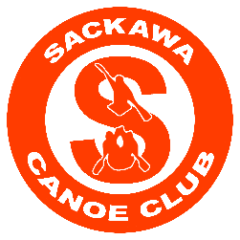

Dear Sir or Madam,
Sackawa Canoe Club is a non-profit paddling club on First Lake that has been offering families in
Sackville the opportunity to learn the sport of canoe-kayak since 1978. Youth age 8 and up have
experienced the benefit of participating in a growing sport, while making lifelong friendships in
the process. The club offers a variety of programs from fun weeklong camps, to a summer and year-long development program, which helps develop athletes both physically and mentally.

Over the years, our club has helped to build young athletes who have gone on to compete
successfully, both on a national and international stage. This success can be attributed to strong
coaching staff, who work to create a fun and focused sporting environment for athletes.

The club recently built a new state-of-the-art clubhouse, which will provide athletes the amenities necessary to enhance our already-successful paddling program. The new facility also offers a member’s bar, which provides food and regular entertainment. The facility is also available as a rental venue for weddings and other gatherings. Our goal is to create an environment that will be a community gathering space for many years to come.

Since the club’s beginnings, we have relied heavily on volunteers - for governance, fundraising,
property maintenance, and regatta coordination. We would like to take this opportunity to thank you for your support of Sackawa Canoe Club and our children. If you are able to make a donation, please contact us: manager@sackawa.ca. If you would like further information on our club, please visit our website at www.sackawa.ca.

Thank you in advance for your support. We look forward to hearing from you.
Sincerely,
Sackawa Canoe Club

Sackawa Canoe Club |159 First Lake Drive | Lower Sackville, NS, B4C 3J9 | 902-252-7225

